Project Design Phase-II
Data Flow Diagram
& User Stories
Date | 27 September 2026
Team ID | [SWTID-2026-9584]
Project Name | Streamlining IT Procurement: Automating Standard Laptop Orders with Flow Designer
Maximum Marks | 4 Marks

Data Flow Diagrams:
A Data Flow Diagram (DFD) shows how data moves through the system — how a request enters, what transforms it, where it is stored, and who acts on it. The Level-1 DFD below maps the standard laptop procurement and configuration process end to end.
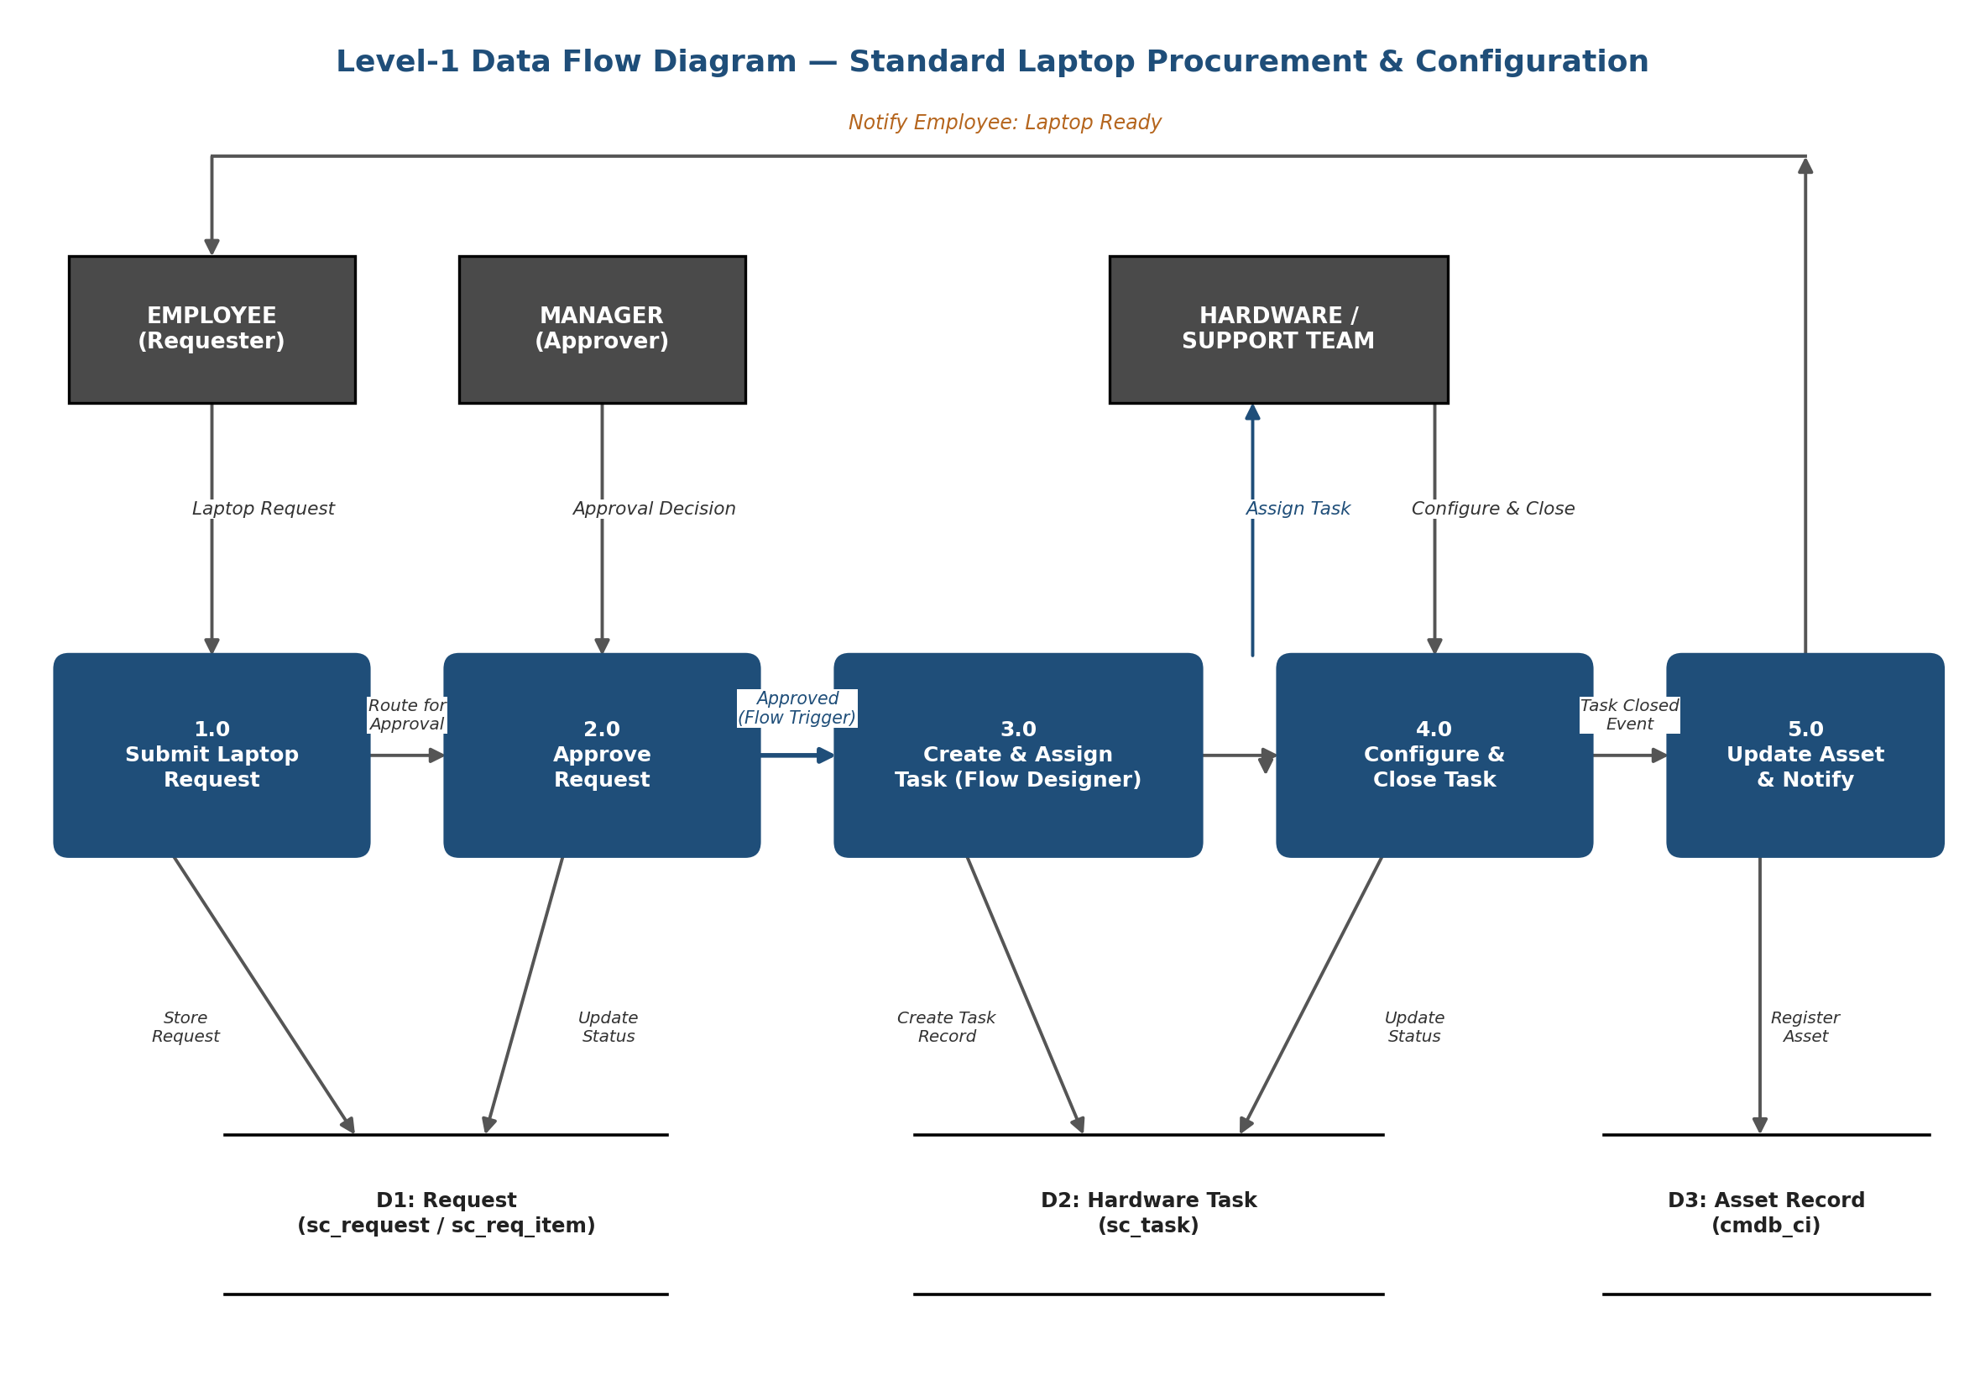

User Stories
The table below lists the user stories for each user type affected by this solution:
User Type | Functional Requirement (Epic) | USN | User Story / Task | Acceptance Criteria | Priority | Release
Employee (Requester) | Laptop Request Submission | USN-1 | As an employee, I can submit a standard laptop request through the Service Catalog so that I don't have to email IT manually. | Request appears in “My Requests” with a tracking number | High | Sprint-1
Employee (Requester) | Laptop Request Submission | USN-2 | As an employee, I want my department and manager fields auto-filled from my profile so that I don't enter them manually. | Fields are pre-populated and read-only | Medium | Sprint-1
Employee (Requester) | Status Tracking & Notifications | USN-3 | As an employee, I receive an email once my laptop is configured and ready for pickup so that I know when to collect it. | Email sent within minutes of task closure | High | Sprint-2
Manager (Approver) | Approval Workflow | USN-4 | As a manager, I can approve or reject a laptop request from my ServiceNow inbox so that I don't need a separate ticket. | Approval action updates request status immediately | High | Sprint-1
Manager (Approver) | Approval Workflow | USN-5 | As a manager, I can add a rejection reason so the requester understands why the request was declined. | Reason is visible to the requester on rejection | Medium | Sprint-2
IT Procurement Team | Status Tracking & Notifications | USN-6 | As an IT procurement team member, I can view a dashboard of all pending / in-progress laptop requests to track turnaround. | Dashboard shows stage, requester and elapsed time | Medium | Sprint-2
IT Procurement Team | Automated Task Creation & Assignment | USN-7 | As an IT procurement team member, I don't have to manually create a hardware task once a request is approved — it happens automatically. | Task auto-created within 1 minute of approval | High | Sprint-1
Hardware / Support Team | Automated Task Creation & Assignment | USN-8 | As a Hardware team member, I automatically receive a configuration task assigned to my group as soon as a request is approved. | Task appears in my group's queue with correct priority | High | Sprint-1
Hardware / Support Team | Automated Task Creation & Assignment | USN-9 | As a Hardware team member, I can close the task once configured, which auto-updates the request and notifies the requester. | Closing task triggers stage update & notification | High | Sprint-1
Hardware / Support Team | Automated Task Creation & Assignment | USN-10 | As a Hardware team member, I receive an escalation alert if I haven't started a task within 4 hours so that SLAs aren't missed. | Escalation notification sent to team lead | Medium | Sprint-2

